**Program-2**

**A.1 Aim: To implement**

1. Design of static website with HTML5 and CSS tags

2. Understand CSS Box Model

3. Understand CSS properties- font, text, background

**A.2 Prerequisite:**

HTML

**A.3 Outcome:**

After successful completion of this experiment students will be able to

1. Understand and implement new HTML 5 tags and make web pages look better by adding CSS.

2. Implement CSS layouts as given below

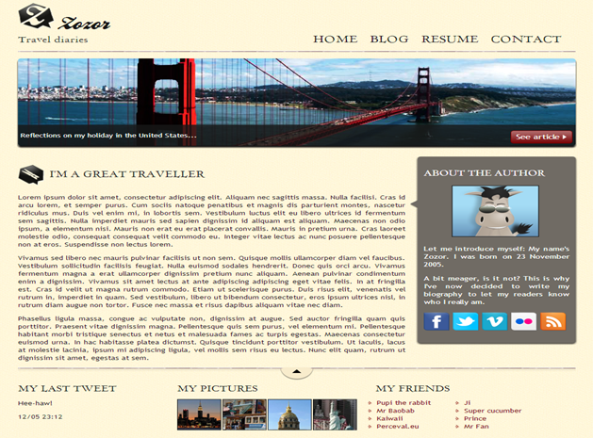

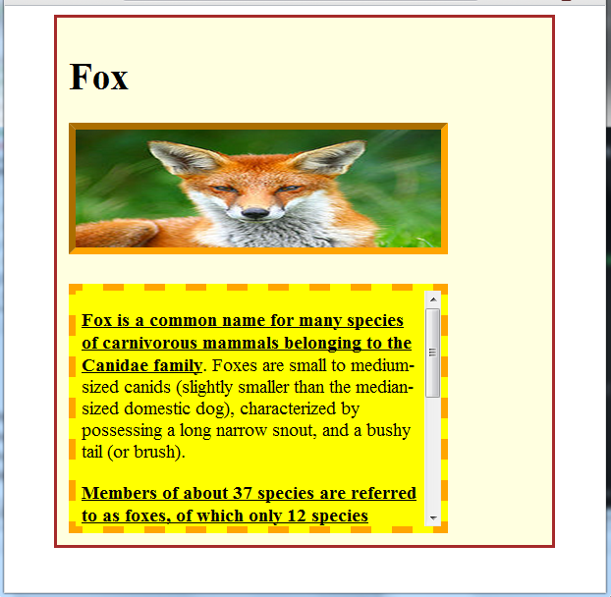

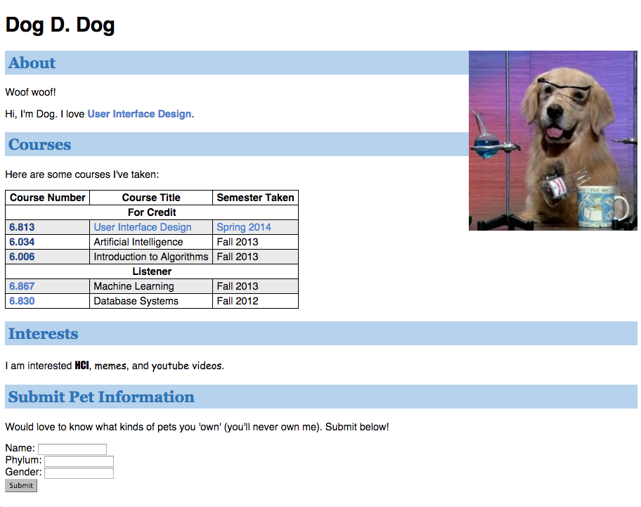

**A.4 Theory:**

* CSS is a language that describes the style of a HTML document.
* CSS describes how HTML elements should be displayed.
* CSS stands for Cascading Style Sheets
* CSS syntax

Selector , declaration

Ex: h1 Selector

{

font-size:12 Declaration

}

* 3 Types of CSS
  + Inline Style
    - CSS code written with the tag we want to apply style with
    - <h1 style="color:blue;margin-left:30px;">This is a heading</h1>
  + Internal Style
    - CSS code written in the head part of the html
    - <head>  
      <style>  
      body {  
          background-color: linen;  
      }  
        
      h1 {  
          color: maroon;  
          margin-left: 40px;  
      }   
      </style>  
      </head>
  + External Style
    - Css code written in external file and file name included in html head
    - <head>  
      <link rel="stylesheet" type="text/css" href="mystyle.css">  
      </head>

**Note: It is left to discretion of students to decide the topic to make website on. Also students are given freedom to learn more tags and implement it much better to improve UI of the web page.**

**PART B**

**(PART B: TO BE COMPLETED BY STUDENTS)**

**(Students must submit the soft copy as per following segments within two hours of the**

**practical. The soft copy must be uploaded on the Blackboard or emailed to the concerned**

**lab in charge faculties at the end of the practical in case the there is no Black board access**

**available)**

**B.1 Software Code written by student:**

**(Students must paste the code here)**

**Zozor**

HTML Code:

<!DOCTYPE html>

<html lang="en">

  <head>

    <link rel="stylesheet" href="styles.css" />

    <link

      href="https://fonts.googleapis.com/css?family=Cedarville Cursive"

      rel="stylesheet"

    />

    <meta charset="UTF-8" />

    <meta http-equiv="X-UA-Compatible" content="IE=edge" />

    <meta name="viewport" content="width=device-width, initial-scale=1.0" />

    <title>Document</title>

  </head>

  <body>

    <header>

      <div class="head">

        <img src="zozor_logo.png" alt="zozor" />

        <h1>Zozor</h1>

        <p>Travel Diaries</p>

      </div>

      <nav class="options">

        <a href="">Home</a>&nbsp&nbsp <a href="">Blog</a>&nbsp&nbsp

        <a href="">Resume</a>&nbsp&nbsp <a href="">Contact</a>

      </nav>

    </header>

    <hr class="h1" />

    <div id="golden-gate">

      <img src="golden_gate.jpg" alt="" />

      <div id="place-desc">

        Reflections on my holiday in the United States...

        <a href="#" class="red-button"> See Article </a>

      </div>

    </div>

    <section>

      <article>

        <h1>

          <img

            src="https://mpmckenz.github.io/Website1/images/pin.png"

            alt=""

          />

          I'M A GREAT TRAVELLER

        </h1>

        <div class="para_class">

          <p style="width: 1000px">

            Lorem ipsum dolor sit amet, consectetur adipiscing elit, sed do

            eiusmod tempor incididunt ut labore et dolore magna aliqua. Ut enim

            ad minim veniam, quis nostrud exercitation ullamco laboris nisi ut

            aliquip ex ea commodo consequat. Duis aute irure dolor in

            reprehenderit in voluptate velit esse cillum dolore eu fugiat nulla

            pariatur. Excepteur sint occaecat cupidatat non proident, sunt in

            culpa qui officia deserunt mollit anim id est laborum.

          </p>

          <br />

          <p style="width: 1000px">

            Sed ut perspiciatis unde omnis iste natus error sit voluptatem

            accusantium doloremque laudantium, totam rem aperiam, eaque ipsa

            quae ab illo inventore veritatis et quasi architecto beatae vitae

            dicta sunt explicabo. Nemo enim ipsam voluptatem quia voluptas sit

            aspernatur aut odit aut fugit, sed quia consequuntur magni dolores

            eos qui ratione voluptatem sequi nesciunt.Neque porro quisquam est,

            qui dolorem ipsum quia dolor sit amet, consectetur, adipisci velit,

            sed quia non numquam eius modi tempora incidunt ut labore et dolore

            magnam aliquam quaerat voluptatem. Ut enim ad minima veniam, quis

            nostrum exercitationem ullam corporis suscipit laboriosam, nisi ut

            aliquid ex ea commodi consequatur? Quis autem vel eum iure

            reprehenderit qui in ea voluptate velit esse quam nihil molestiae

            consequatur, vel illum qui dolorem eum fugiat quo voluptas nulla

            pariatur?

          </p>

          <br />

          <p style="width: 1000px">

            At vero eos et accusamus et iusto odio dignissimos ducimus qui

            blanditiis praesentium voluptatum deleniti atque corrupti quos

            dolores et quas molestias excepturi sint occaecati cupiditate non

            provident, similique sunt in culpa qui officia deserunt mollitia

            animi, id est laborum et dolorum fuga. Et harum quidem rerum facilis

            est et expedita distinctio. Nam libero tempore, cum soluta nobis est

            eligendi optio cumque nihil impedit quo minus id quod maxime placeat

            facere possimus, omnis voluptas assumenda est, omnis dolor

            repellendus. Temporibus autem quibusdam et aut officiis debitis aut

            rerum necessitatibus saepe eveniet ut et voluptates repudiandae sint

            et molestiae non recusandae. Itaque earum rerum hic tenetur a

            sapiente delectus, ut aut reiciendis voluptatibus maiores alias

            consequatur aut perferendis doloribus asperiores repellat.

          </p>

        </div>

      </article>

    </section>

    <div class="right-sect">

      <div class="right-sect-heading">

        <h1 class="abt">About the author</h1>

        <img

          class="abt"

          src="https://mpmckenz.github.io/Website1/images/zozor.png"

          id="smalli"

        />

        <img

          src="https://mpmckenz.github.io/Website1/images/arrow.png"

          class="arrow"

        />

        <br />

        <p>

          Let me introduce myself: My name's Zozor. I was born on 23 November

          2005.

        </p>

        <p>

          A bit meager, is it not? This is why I've now decided to write my

          biography to let my readers know who I really am.

        </p>

      </div>

      <div class="socialmedia">

        <div>

          <img src="https://mpmckenz.github.io/Website1/images/facebook.png" />

        </div>

        <div>

          <img src="https://mpmckenz.github.io/Website1/images/twitter.png" />

        </div>

        <div>

          <img src="https://mpmckenz.github.io/Website1/images/vimeo.png" />

        </div>

        <div>

          <img src="https://mpmckenz.github.io/Website1/images/flickr.png" />

        </div>

        <div>

          <img src="https://mpmckenz.github.io/Website1/images/rss.png" />

        </div>

      </div>

    </div>

    <br />

    <hr />

    <footer class="foot">

      <div class="navigate">

        <div class="tweet">

          <h1>MY LAST TWEET</h1>

          <h4>Hee-haw!</h4>

          <h4>12/05 23:12</h4>

        </div>

        <div class="mypics">

          <h1>MY PICTURES</h1>

          <div class="pic-source">

            <div style="border: 1px solid black">

              <img src="https://mpmckenz.github.io/Website1/images/pic1.jpg" />

            </div>

            <div style="border: 1px solid black">

              <img src="https://mpmckenz.github.io/Website1/images/pic2.jpg" />

            </div>

            <div style="border: 1px solid black">

              <img src="https://mpmckenz.github.io/Website1/images/pic3.jpg" />

            </div>

            <div style="border: 1px solid black">

              <img

                src="https://mpmckenz.github.io/Website1/images/pic4.jpg"

                alt=""

              />

            </div>

          </div>

        </div>

        <div class="d3">

          <h1>MY FRIENDS</h1>

          <div class="nav_parent1">

            <div>

              <ul>

                <li>Pupl the Rabbit</li>

                <li>Mr. Baobab</li>

                <li>Kalwali</li>

                <li>Perceval.eu</li>

              </ul>

            </div>

            <div>

              <ul>

                <li>Ji</li>

                <li>Super Cucumber</li>

                <li>Prince</li>

                <li>Mr Fan</li>

              </ul>

            </div>

          </div>

        </div>

      </div>

    </footer>

  </body>

</html>

CSS:

body {

  background-color: beige;

}

.head h1 {

  position: absolute;

  left: 80px;

  top: 0px;

  font-style: italic;

  font-size: 30px;

}

.head p {

  font-size: 17px;

}

.options {

  position: absolute;

  top: 65px;

  right: 60px;

  font-size: x-large;

  padding: 10px 10px 10px 10px;

}

hr {

  color: gray;

  border: 0.8px solid;

}

#golden-gate {

  background-repeat: no-repeat;

  height: 200px;

  position: relative;

  margin-top: 15px;

  width: 1510px;

}

#golden-gate img {

  width: 1510px;

  height: 200px;

}

#place-desc {

  position: absolute;

  bottom: 0;

  width: 99.5%;

  height: 33px;

  padding-top: 15px;

  padding-left: 4px;

  background-color: rgb(24, 24, 24);

  color: white;

  font-size: 0.85em;

}

.red-button {

  height: 25px;

  position: absolute;

  right: 5px;

  bottom: 5px;

  background-color: rgba(150, 11, 11, 0.938);

  border: 1px solid #760001;

  border-radius: 5px;

  font-size: 1.2em;

  text-align: center;

  padding: 3px 8px 0px 8px;

  color: white;

}

section h1 {

  font-family: Georgia;

  font-weight: lighter;

}

/* .abt {

  margin-left: 80px;

  text-align: center;

} */

/* #right-sect {

  position: absolute;

  background-color: rgb(109, 107, 107);

  color: aliceblue;

  left: 580px;

  top: 400px;

  width: 20%;

  padding-left: 30px;

  border-radius: 1em;

} */

.text {

  text-align: center;

}

#zozor-img {

  text-align: center;

}

.right-sect {

  width: 300px;

  height: fit-content;

  position: absolute;

  background-color: rgb(112, 107, 100);

  padding-left: 10px;

  padding-right: 10px;

  padding-bottom: 10px;

  border-radius: 5px;

  top: 390px;

  left: 1190px;

}

.right-sect-heading {

  text-align: center;

  color: white;

}

.arrow {

  position: relative;

  right: 237px;

}

.socialmedia {

  display: flex;

  flex-direction: row;

  margin-left: 25px;

  margin-right: 25px;

  align-content: center;

  gap: 10px;

}

.navigate {

  display: flex;

  flex-direction: row;

  justify-content: space-between;

}

.pic-source {

  display: flex;

  flex-direction: row;

  gap: 10px;

}

li {

  display: grid;

  grid-template-columns: 20px auto;

  justify-content: start;

  align-items: center;

  color: rgb(162, 0, 1);

}

li::before {

  content: ">";

  font-size: 10px;

  color: rgb(162, 0, 1);

}

.nav_parent1 {

  display: flex;

  flex-direction: row;

  margin-right: 95px;

}

.d3 h1 {

  margin-left: 55px;

}

.para-class p {

  width: 10%;

}

**Fox:**

HTML Code:

<!DOCTYPE html>

<html lang="en">

  <head>

    <link rel="stylesheet" href="styles.css" />

    <meta charset="UTF-8" />

    <meta http-equiv="X-UA-Compatible" content="IE=edge" />

    <meta name="viewport" content="width=device-width, initial-scale=1.0" />

    <title>Document</title>

  </head>

  <body>

    <h1>Fox</h1>

    <div class="fox-image">

      <img src="fox2.jpg" alt="fox-img" />

    </div>

    <div class="text-box">

      <p>

        <strong

          ><u

            >Fox is a common name for many species of carnivorous mammals

            belonging to the Canidae family.

          </u></strong

        >Foxes are small to medium-sized canids(slightly smaller than the

        median-sized domestic dog), characterized by possesing a long narrow

        snout, and a bushy tail(or brush).

      </p>

      <br />

      <p>

        <b

          ><u

            >Members of about 37 species are referred to as foxes, of which only

            12 species actually belong to the Vulpes genus of 'true foxes'.

          </u></b

        >By far the most common and widespread species of fox is the red fox

        (Vulpes vulpes), although various species are found on almost every

        continent.

      </p>

    </div>

  </body>

</html>

**CSS:**

body {

  background-color: beige;

  border-left: 5px solid red;

  border-bottom: 5px solid red;

}

img {

  width: 40%;

  height: 30%;

  border: 10px solid orange;

}

.fox-image {

  margin-bottom: 10px;

}

.text-box {

  overflow-y: scroll;

  background-attachment: scroll;

  background-color: yellow;

  padding: 2%;

  margin-top: 0px;

  border: 8px dashed orange;

  width: 550px;

  height: 200px;

}

**Dog D. Dog**

HTML Code:

<!DOCTYPE html>

<html lang="en">

  <head>

    <link rel="stylesheet" href="styles.css" />

    <meta charset="UTF-8" />

    <meta http-equiv="X-UA-Compatible" content="IE=edge" />

    <meta name="viewport" content="width=device-width, initial-scale=1.0" />

    <title>Document</title>

  </head>

  <body>

    <div class="dog-image">

      <img id="img1" src="dogs.jpg" alt="dog-img" />

    </div>

    <h1>Dog D. Dog</h1>

    <div class="section">

      <h2>About</h2>

      <p>Woof woof <br /></p>

      <p>

        Hi,I'm Dog. I love

        <span style="color: blue">User Interface Design</span>

      </p>

    </div>

    <div class="section">

      <h2>Courses</h2>

    </div>

    <table class="t1">

      <thead>

        <tr>

          <th>Course Number</th>

          <th>Course Title</th>

          <th>Semester Taken</th>

        </tr>

      </thead>

      <tbody>

        <tr>

          <td class="enrollheader" colspan="3">For Credit</td>

        </tr>

        <tr class="currentlytaking">

          <td>

            <a class = "p1">6.813</a>

          </td>

          <td>User Interface Design</td>

          <td>Spring 2014</td>

        </tr>

        <tr>

          <td>

            <a class = "p1">6.034</a>

          </td>

          <td>Artificial Intelligence</td>

          <td>Fall 2013</td>

        </tr>

        <tr>

          <td>

            <a class = "p1">6.006</a>

          </td>

          <td>Introduction to Algorithms</td>

          <td>Fall 2013</td>

        </tr>

        <tr>

          <td class="enrollheader" colspan="3">Listener</td>

        </tr>

        <tr>

          <td>

            <a class = "p2">6.867</a>

          </td>

          <td>Machine Learning</td>

          <td>Fall 2013</td>

        </tr>

        <tr>

          <td class = "p2">6.830</></td>

          <td>Database Systems</td>

          <td>Fall 2012</td>

        </tr>

      </tbody>

    </table>

    <div class="section">

      <h2>Interests</h2>

      <p>I am interested <strong>HCI</strong>,meme, and youtube videos</p>

    </div>

    <div class="section">

      <h2>Submit Pet Information</h2>

      <p>

        Would love to know what kinds of pets you "own"(you'll never own me).

        Submit below!

      </p>

    </div>

    <form>

      <table class = "forms1">

        <tr>

          <td>

            <label for="petname"><strong>Name: &nbsp;</strong></label>

          </td>

          <td><input id="petname" type="text" name="petname" /><br /></td>

        </tr>

        <tr>

          <td>

            <label for="phylum"><strong>Phylum</strong>:</label>

          </td>

          <td><input id="phylum" type="text" name="phylum" /><br /></td>

        </tr>

        <tr>

          <td>

            <label for="gender"><strong>Gender:</strong></label>

          </td>

          <td><input id="gender" type="text" name="gender" /><br /></td>

        </tr>

      </table>

      <input type="submit" value="Submit" />

    </form>

  </body>

</html>

CSS Code:

.dog-image {

  align-items: right;

}

#img1 {

  position: absolute;

  top: 80px;

  right: 0px;

  width: 20%;

  height: 30%;

}

.t1 {

  border-collapse: collapse;

}

.t1 tr:nth-child(even) {

  background-color: #eaeaea;

}

.t1 tr.currentlytaking {

  color: #337ed2;

}

.t1 td.enrollheader {

  background-color: white;

  text-align: center;

  font-weight: bold;

}

.t1 th,

.t1 td {

  border: 1px solid black;

}

.section {

  font-size: 16px;

}

.section h2 {

  background-color: #b6d2ec;

  font-family: Georgia;

  color: #2a75ba;

  padding: 5px;

}

.p1 {

  color: #094c86;

  font-weight: bold;

}

.p2 {

  color: #2a75ba;

  font-weight: bold;

}

.forms1 {

  border: 0px;

}

**B.2 Input and Output**

**(Students must paste input and output here)**

**Zozor:**

**Fox:**

**B.3. Observations and Learning**

**(Students are expected to comment on the output obtained with clear observations and learning for each task/ sub part assigned**

We learnt about box model in CSS and how to link CSS page with html. We also learnt about various attributes used for different tags and how to edit them in CSS. We also learnt about CSS properties like font, text, and background.

**B.4. Conclusion**

**(Students must write the conclusion as per the attainment of individual outcome listed above and learning/observation noted in Sec. B.3)**

From the following experiment, we can conclude that we learnt about the CSS Box model, learnt about various properties of HTML, and also implement CSS layouts.